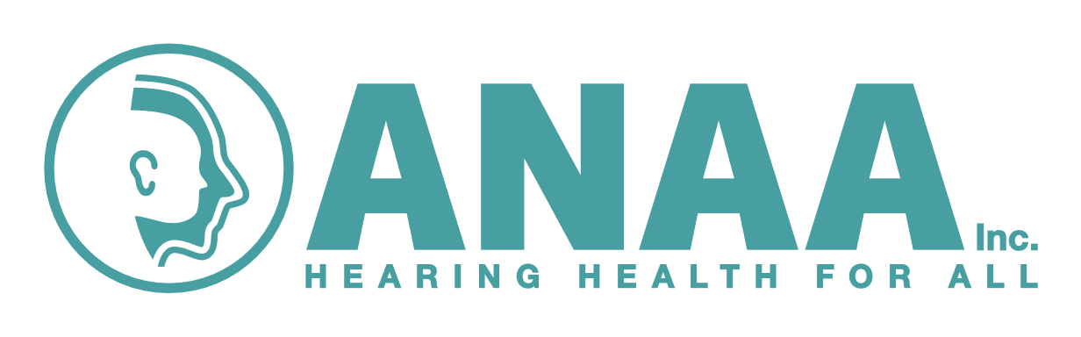

**CLINICAL COMPETENCIES**

**For**

**AUDIOMETRY NURSES**

Name:

Site:

Date:

These competencies may be assessed in conjunction with the ANAA Inc.

Clinical Practice Review *(ANAA Inc. Clinical Practice Standards 2021)*

**CLINICAL COMPETENCIES for AUDIOMETRY NURSES**

The professional organisation for audiometry nurses, the ***Audiometry Nurses Association of Australia Inc****,* has developed a set of seven (7) Clinical Competencies which must be achieved by students in audiometry nursing, and maintained by practicing audiometry nurses. These competencies should be used in conjunction with the ***ANAA Inc Clinical Practice Standards for Audiometry Nurses (2021.).***

The clinical competencies include the following categories:

1: practices effective communication

2: provides comprehensive hearing assessments

3: record, interpret, report and explanation of results to client / carer

4: understanding of newborn hearing screening programs

5: case management in consultation with client / others

6: maintenance of equipment and environment

7: professional and clinical issues

**Competency 1: Practices effective communication**

|  |  |  |
| --- | --- | --- |
| **Criteria** | **Competent**  **Y/N** | **Date** |
| Establishes and maintains rapport with client / carer |  |  |
| Uses age / developmentally appropriate language |  |  |
| Observation of client / family throughout assessment |  |  |
| Shares all relevant information with client / carer |  |  |
| Obtains informed consent |  |  |
| Provides appropriate explanation of procedures and results |  |  |
| Uses culturally appropriate language and approach |  |  |
| Seeks peer support / supervision for complex situations |  |  |

**Competency 2: Provides comprehensive hearing assessments**

|  |  |  |
| --- | --- | --- |
| **Criteria** | **Competent**  **Y/N** | **Date** |
| Conducts comprehensive history taking / interview – child |  |  |
| Conducts comprehensive history taking / interview – adult |  |  |
| Otoscopy - function and safe use / technique |  |  |
| Otoscopy - accurate description of observations |  |  |
| Tympanometry - function and safe use / technique |  |  |
| Tympanometry - interpretation and description of results |  |  |
| Tympanometry - identifies and records presence / absence of acoustic reflexes and understands their relevance |  |  |
| Pure tone audiometry (air conduction) – Hughson Westlake technique |  |  |
| Pure tone audiometry (air conduction) – plotting of results |  |  |
| Pure tone audiometry (bone conduction) – Hughson Westlake technique |  |  |
| Pure tone audiometry (bone conduction) – plotting of results |  |  |
| Masking (air conduction) – rules of masking |  |  |
| Masking (air conduction) – technique |  |  |
| Masking (air conduction) – plotting of results |  |  |
| Masking (bone conduction) – rules of masking |  |  |
| Masking (bone conduction) – technique |  |  |
| Masking (bone conduction) – plotting of results |  |  |
| Free field screening – VRA / PA5 technique |  |  |
| Free field screening – VRA / PA5 plotting of results |  |  |
| Hearing screening using PA5 with earphone |  |  |
| Manages challenging behaviours |  |  |
| Uses developmentally appropriate testing / screening techniques |  |  |
| Demonstrates Audiometric Weber – use and limitations |  |  |
| Demonstrates knowledge of occupational screening standards and procedures |  |  |

**Competency 3: Record, interpret, report and explanation of results to**

**client / carer**

|  |  |  |
| --- | --- | --- |
| **Criteria** | **Competent**  **Y/N** | **Date** |
| Use of appropriate clinical forms for hearing clinic |  |  |
| Accurate plotting and recording of results |  |  |
| Use of appropriate symbols |  |  |
| Accurate interpretation of all findings including masking |  |  |
| Written report using appropriate terminology which reflects results |  |  |
| Appropriate explanation of results to client / carer - culturally acceptable |  |  |

**Competency 4: Understanding of newborn hearing screening programs**

|  |  |  |
| --- | --- | --- |
| **Criteria** | **Competent**  **Y/N** | **Date** |
| Explains the difference between AABR and OAE |  |  |
| Observes newborn hearing screening |  |  |
| Demonstrates knowledge of risk factors associated with progressive sensorineural hearing loss |  |  |
| Demonstrates knowledge of follow up process for infants and children with risk factors for progressive hearing loss |  |  |

**Competency 5: Case management in consultation with client / others**

|  |  |  |
| --- | --- | --- |
| **Criteria** | **Competent**  **Y/N** | **Date** |
| Recalls client for review if appropriate |  |  |
| Refer client to other agencies / disciplines / organisations as appropriate |  |  |
| Provides client / carer with appropriate hearing health resources |  |  |
| Advocates on behalf of client |  |  |
| Uses other strategies to optimise client outcomes |  |  |

**Competency 6: Maintenance of equipment and environment**

|  |  |  |
| --- | --- | --- |
| **Criteria** | **Competent**  **Y/N** | **Date** |
| Equipment check prior to commencing clinic |  |  |
| Annual calibration requirements |  |  |
| Use and limitations of all equipment |  |  |
| Knowledge and understanding of relevant standards for audiometric testing environment and equipment calibration |  |  |
| Troubleshooting / problem solving |  |  |

**Competency 7: Professional and clinical issues**

|  |  |  |
| --- | --- | --- |
| **Criteria** | **Competent**  **Y/N** | **Date** |
| Adherence to local and State workplace health and safety policies |  |  |
| Adherence to relevant infection control policies |  |  |
| Ethical and legal considerations in all aspects of client care |  |  |
| Adherence to all relevant local policies and procedures |  |  |
| Practices in accordance with recommended professional and national nursing standards including audiometry nursing clinical practice standards and competencies |  |  |

Clinician’s name: Designation:

Signature

Date:

Assessor’s name: Designation:

Signature:

Date:

*Further information relating to these clinical competencies should be directed to the executive committee of the Audiometry Nurses Association of Australia Inc.*